In order to complete the project, these are the list of technologies used and the purposes they served

* Twig: a powerful template engine in symfony used to render content
* CSS: style sheets used in restructuring the website and adding beauty to it
* Symfony:Symfony is a good all-purpose PHP framework. It is very configurable, has great features, and provides tons of plug-ins to ease development
* Bootstrap:
* Revolution js
* Custom JavaScript: scripts like fancy js, mail function js, masonry,isotope Effect Js and imagesloaded Js. All used to make the site more dynamic and animated.
* MYSQL databases: Used to store site information
* GIT: Used for version control and committing changes to the cloud
* Swift Mailer: Connecting the App to a mailing service
* Material design admin dashboard template
* cleanix front end template.

2: Description of the project

The project task was to develop a business website with symfony( a PHP framework). As a business website, it has to be able to easily communicate the business to visitors and find a way of easily engaging them. The project required a responsive fast loading site, since some of its users will be using a mobile device. To tackle this problem the project sought for a solution using the PHP framework.

3:these are the various problems or milestones that the project solved.

* Easy navigable site
* responsive site
* contact form to engage with visitors.
* Blog section with updates from a dashboard
* A list of all the mails sent through the contact form
* flash messages to inform visitors of any ongoing promotion
* light weight site that loads faster even on slow internet speeds

4: the most technical concern apart from responsiveness was the security of the site.

6:Functioning of the website

The page which loads when the website link is visited is the homepage.

The first noticeable feature of the homepage, which is same on every other page is the navigation bar.

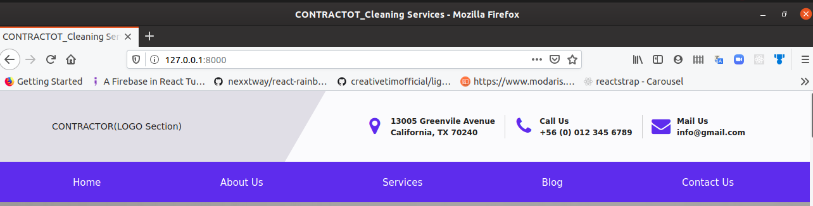

The navigation bar( nav bar) has two prominent sections, which is the logo and contact details section and the the navigation links section. These navigation links open up the various pages.

Upon scroll the logo and contact details section disappear while the navigation links section sticks to the to of the window.

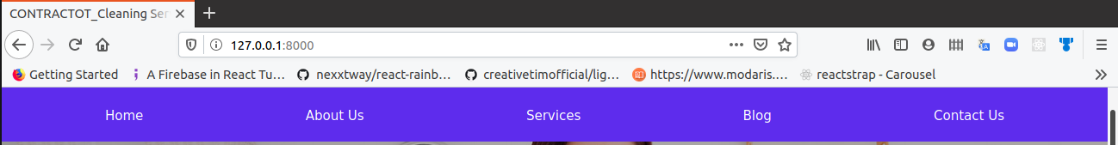

On mobile, logo appears on the navigation bar with a toggle button at the extreme right of the page. Upon clicking this toggle button, the navigation links show up.

Toggle button



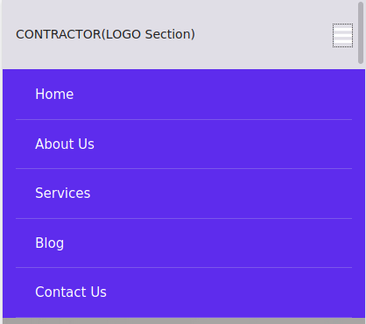

Fig: Functioning of the navigation bar in mobile mode

The next section after the nav bar is a carousel( Content slider) Section.

It contains an image and content on top of it that changes over time or upon click of the slider control arrows.

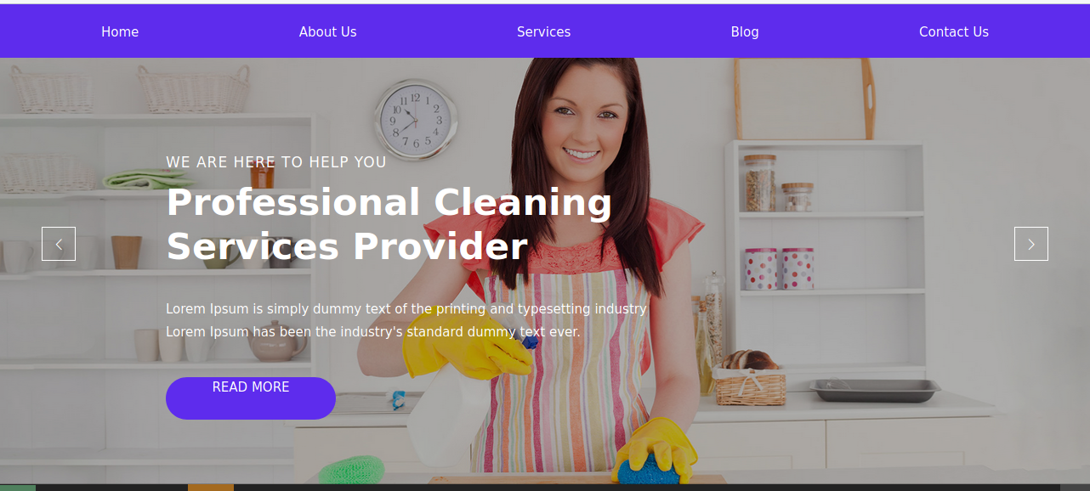

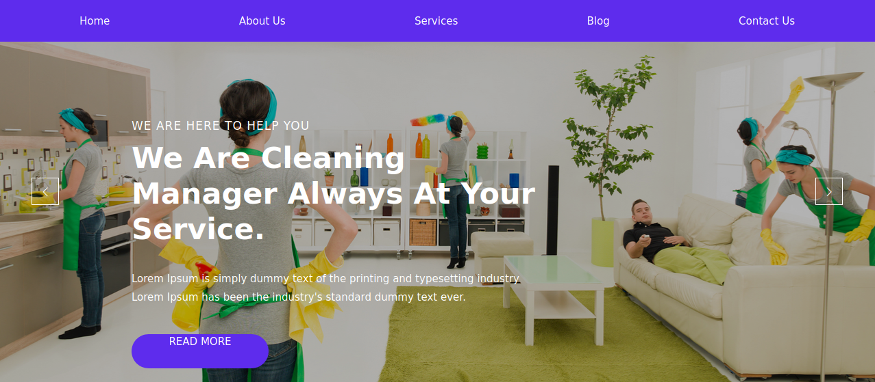

Fig: Carousel Section of homepage

on mobile, this section is very responsive



Fig: Responsive view of carousel section on mobile.

Upon scroll of the page, we meet the about us section, which gives a brief about the business.

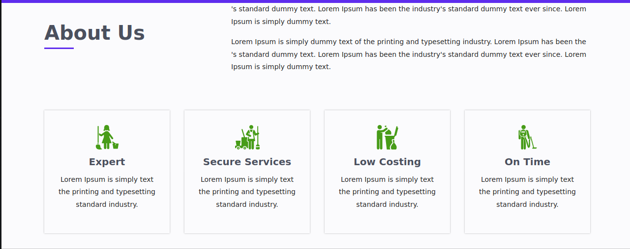

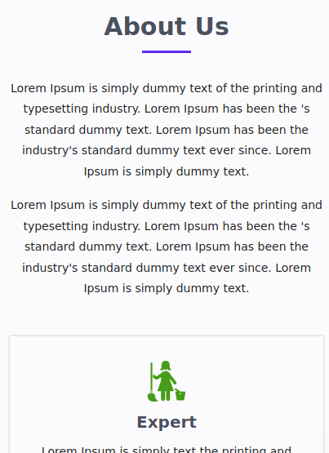

Fig: About Us section on Home Page

Just after the about section is the services section. It has a slider with services cards. The cards are being controlled by a control arrow at the bottom of the cards.

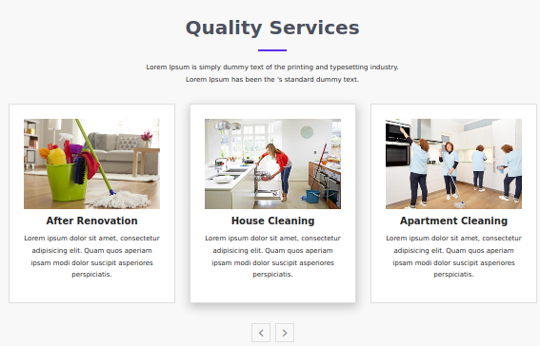

Fig: Services section on homepage on desktop view above and mobile view below

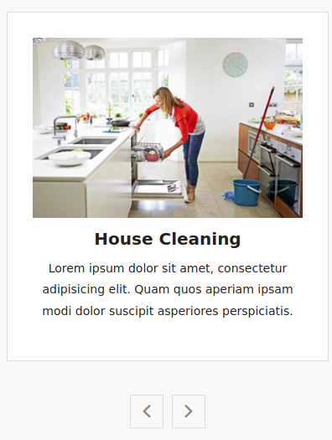

The next section is a quick action section, which features an email input form in order to sign up for a newsletter.

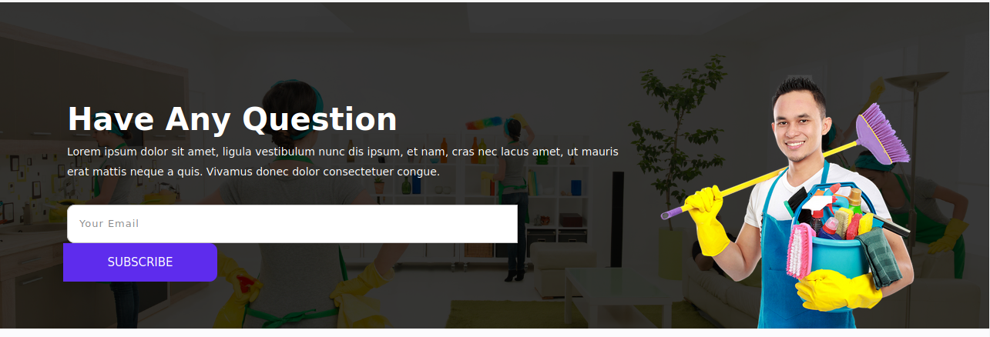

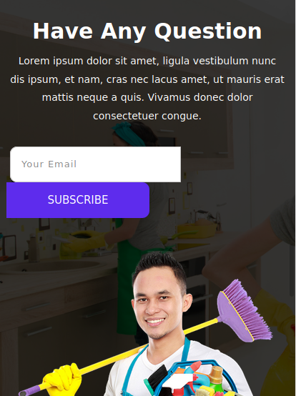

Fig: Desktop and mobile view of the newsletter section

Just below this section is a blogs sections that features random articles from the blog stored on the database. It shows clickable blog cards with an image, date, title and short description.

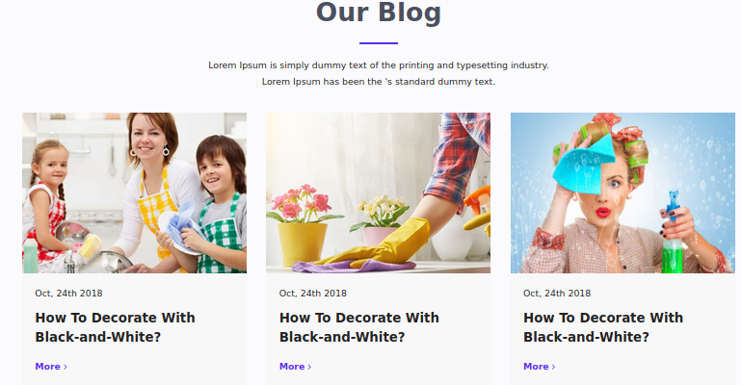



Fig: Blog section desktop and mobile view

And Finally on the homepage is the footer section which contain some links to various pages in the website, a newsletter form and a background image of a city.

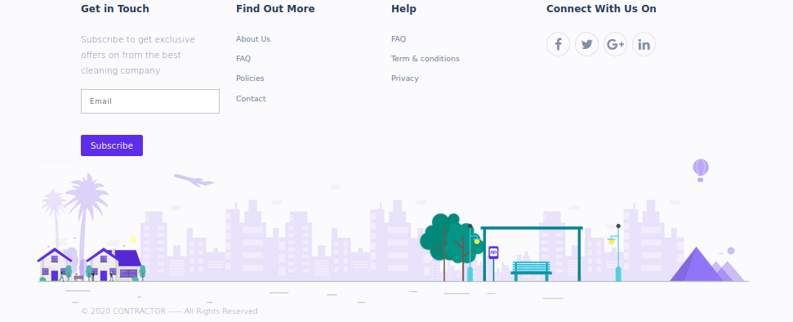

**The About Page:**

The about page contains all the necessary information about the company that is relevant to the client. It starts with a navigation bar which is same as that on the homepage. It starts with a brief about the companies mission, vision and work statement. It then list some reasons why a client should choose to work with them, a brief history about the company and then a picture card area of the main key members of the company.

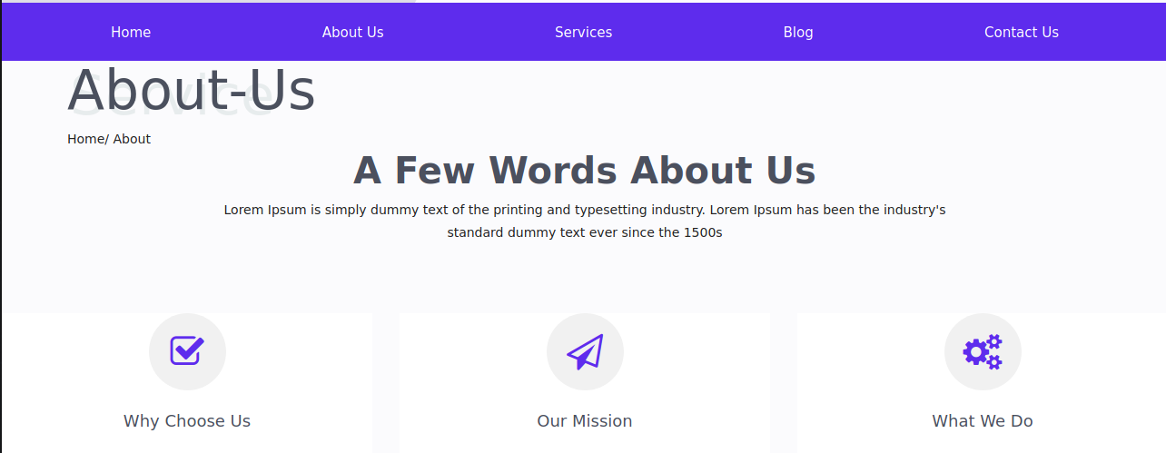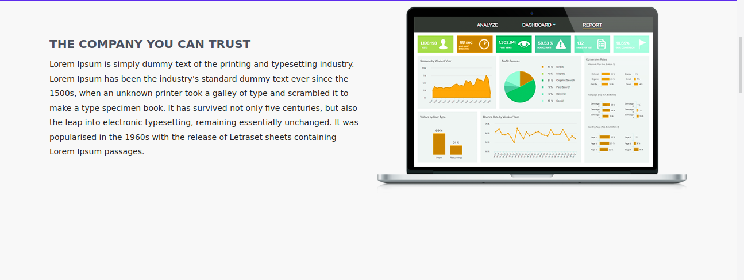

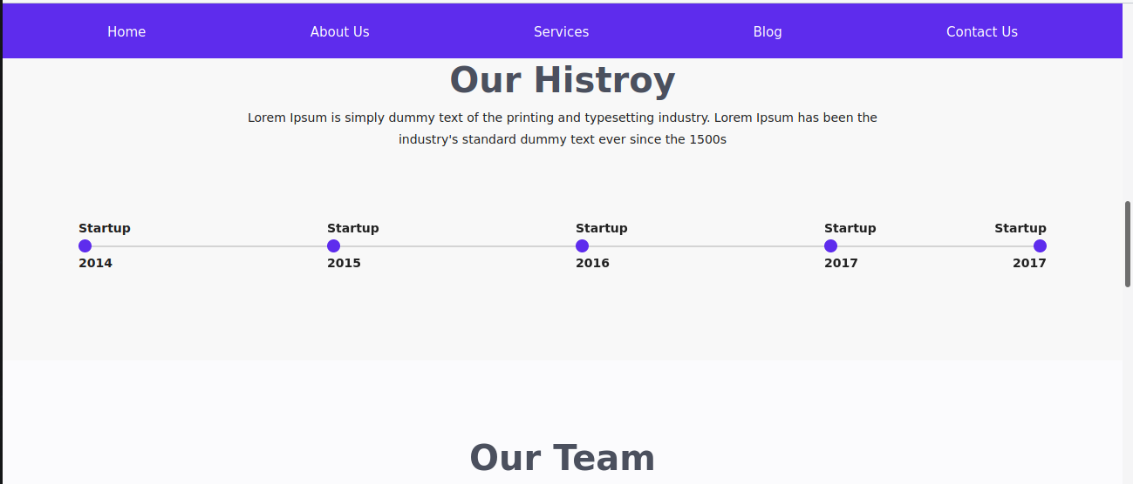

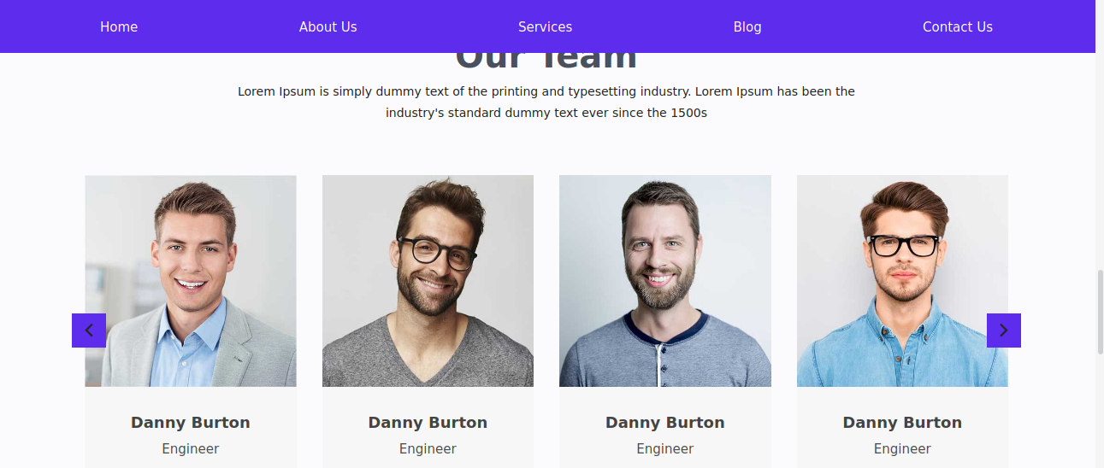

The about page ends with a footer section which is same as on every other page.

**The Services page:**